**DELETE CODE**

**Delete these code from 4th ns3 lab program**

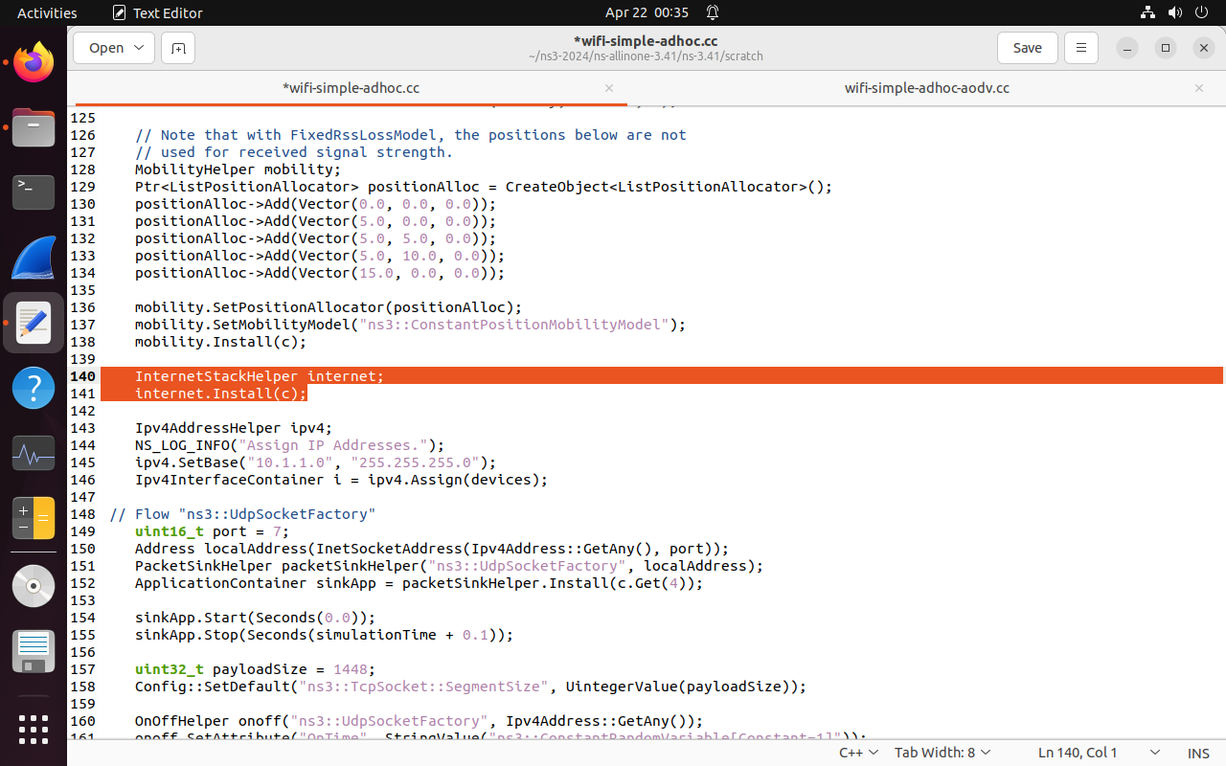

**CHANGES IN CODE**

**Everything remains same as 4th ns3 lab program but delete that 2 line and paste these 4 line code**

Paste these 4 line code instead of the previous 2 line code

AodvHelper aodv;

InternetStackHelper internet;

internet.SetRoutingHelper(aodv);

internet.Install(c);